Re-engineering Research Outcomes

Objective

Today’s homework assignment begins with a published research finding and traces a published research finding back to its original data source. We refer to this as deconstructing or re-engineering an analysis.

You will need to identify from a published article the variables that are mentioned in the study and chart this information so that you will be able to locate, extract, and download these variables and data from the online data extraction service for the U.S. General Social Survey on Wednesday.

Instructions

Read the following extracts from three articles that reference the U.S. General Social Survey and identify the variables and/or subsets of cases used in these studies.

1) As you read each article, circle words that describe variables and/or their values. These words may be a mix of nouns, adjectives and verbs. For example, “Men drink more than women” includes nouns (men and women) that are categories of sex (i.e., value labels for sex). The verb drink implies a measure of drinking behavior. One would expect to find two variables (sex and drinking behavior) to deconstruct this finding.

2) The first instruction applies to written research summaries. Some findings will be reported in a table or graph. In these instances, identify from the table heading or its contents the variable or variables it displays. Pay particular attention in tables to the number of cases reported. These case totals may hint at subsets of the original data file.

Articles Extracts

Read the following extracts from three articles that reference the U.S. General Social Survey and complete the table included to identify the variables mentioned in the study.

I. Sherkat, Darren E. “Tracking the "Other": Dynamics and composition of "other" religions in the General Social Survey, 1973-1996”. Journal for the Scientific Study of Religion, Dec99, Vol. 38, Issue 4, pp. 551-560.

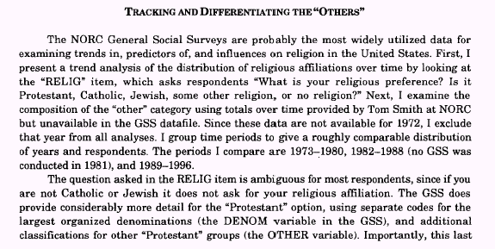
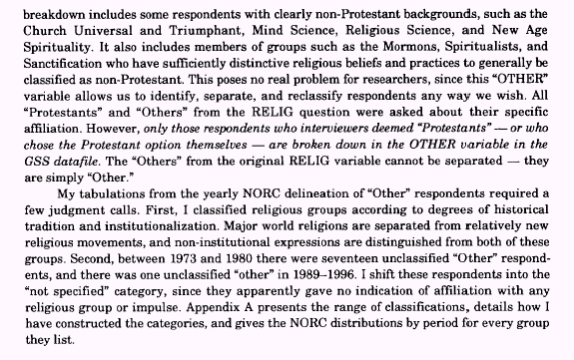
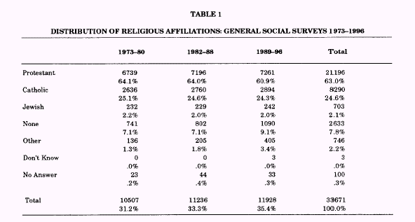

A.
General Social Survey Cumulative File
Variables (either the topical name of the variable or its name in the data file)
Cases (any special case groupings? in what way?):

B. Is the level of detailed information discussed in the Sherkat article available for the “Other” variable in the public use version of the GSS? Why or why not?

II. Goldman, Debra. “Consumer Republic: Americans disagree about life; we can agree on death”. ADWEEK, December 11, 2000, p. 20.

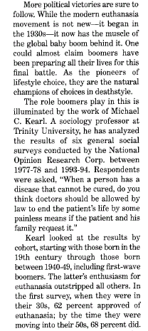 | 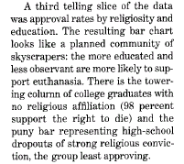

General Social Survey Cumulative File
Variables (topical name and/or recoding of variables)
Cases (any special case groupings? in what way?):

III. Lewis, Gregory B and Sue A. Frank. “Who Wants to Work for the Government?” Public Administration Review, Jul/Aug 2002, Vol. 62, Issue 4, pp. 395-404.

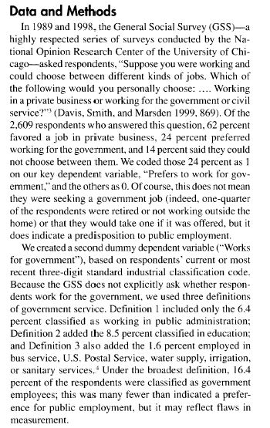 | 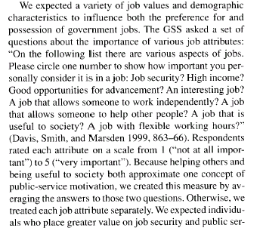  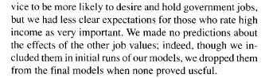
(Continue on the next page to record your findings.)

General Social Survey Cumulative File
Variables (topical name and/or recoding of variables)
Cases (any special case groupings? in what way?):

